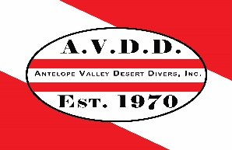Antelope Valley Desert Divers Scholarship Application

Scholarship Year ___________

Scholarship Type:

New Diver (Open Water Certification) _______ Continuing Education _______

*Name __________________________________________________________________
*Address _______________________________________________________________
_______________________________________________________________
*Phone (HM) __________________________________________________________
(Cell) __________________________________________________________

*Email _________________________________________________________________________________________

* Required information

If you are applying for the Continuing Education Scholarship, please list your current dive certification and attach a copy.
Certification__________________________________________________________________________________
Certification# and Date_____________________________________________________________________

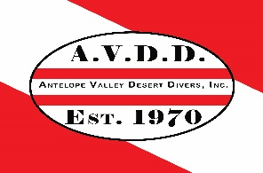Antelope Valley Desert Divers Scholarship Application

For “New Diver Scholarship” applicants please write a minimum one-page essay explaining why you should be considered for this scholarship. Please describe who you are and why you would like to be a scuba diver.

For members applying for the “Continuing Education Scholarship” Please write a minimum one-page essay on why you should be selected for this scholarship. Please include why you want to continue your training and how this would benefit the club. An example of a benefit would be “By receiving this scholarship, it would allow me to become a certified Rescue Diver. This would benefit the AVDD because I am currently the clubs Dive Coordinator, by being a Rescue Diver I will be better prepared for any emergency that could arise during a club dive.”

Once all applications have been received, Applicant will be invited to the February board meeting where they will participate in an oral interview process. This is to allow the Board to better get to know you and help make the final decision.

Good Luck and we look forward to Diving with you.

When the application is completed, signed and dated you may bring it to a general meeting and turn it in along with your essay into any board member or you may mail it to the address listed below. A confirmation email will be sent to you when the application has been received. If no email address is provided a confirmation phone call will be made.

Signature_____________________________________________ Date __________________________

Antelope Valley Desert Divers
38713 Tierra Subida #200-227
Palmdale, CA 93551

